Thank you for downloading

Tricerat's Screwdrivers!

V4.8.03

ScrewDrivers® is a remote desktop print management solution that employs 'driverless' technology to mirror print drivers from the network print server, bypassing the user's end point entirely. Tricerat's TMF print protocol compresses the printer files to achieve the fast and reliable printing users need. No crashes. No lost print jobs. Just printing from any application to any available printer — so users can print without trouble and you can go about your day. This download of Screwdrivers contains all the files you will need to install and use Screwdrivers in an RDP or ICA session for 30 days. During this 30-day period, you have complete access to the Tricerat support center to make sure your evaluation goes smoothly.

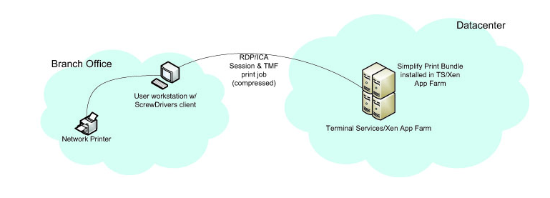

Usage:

Screwdrivers can be used in three types of scenarios:
- A user is connecting to a Server Operating System over an RDP or ICA connection from a client with a desktop or Server Operating System and wants to print to their local printer. i.e. The printer driver is installed on the local computer
- A user is connecting to a Desktop Operating System over an RDP or ICA connection from a client with a desktop of Server Operating System and wants to print to their local printer. i.e. The printer driver is installed on the local computer
- A user is connecting to a remote session over ICA on a Mac and wants to print to their local printer. i.e. The printer driver is installed on the Mac

Manifest:

If you downloaded ScrewDriversv4.8.03x64.zip, the zip file contains:

- ScrewDrivers Client v4 x64.msi – Run this file on your 64-bit client. That is, run this file on the client with the local printer driver installed.
- ScrewDrivers Client v4.msi – Run this file on your 32-bit client. That is, run this file on the client with the local printer driver installed.
- ScrewDrivers Server v4 x64.msi- Run this file on your 64-bit Server. This Server will be your Terminal Server or Citrix XenApp Server.

If you downloaded ScrewDriversv4.8.03.zip, the zip file contains:

- ScrewDrivers Client v4 x64.msi – Run this file on your 64-bit client. That is, run this file on the client with the local printer driver installed.
- ScrewDrivers Client v4.msi – Run this file on your 32-bit client. That is, run this file on the client with the local printer driver installed.
- ScrewDrivers Server v4 x64.msi - Run this file on your 32-bit Server. This Server will be your Terminal Server or Citrix XenApp Server.

If you downloaded ScrewDriversv4.8.03x64rdc.zip, the zip file contains:

- ScrewDrivers Client v4 x64.msi – Run this file on your 64-bit client. That is, run this file on the client with the local printer driver installed.
- ScrewDrivers Client v4.msi – Run this file on your 32-bit client. That is, run this file on the client with the local printer driver installed.
- ScrewDrivers Server v4 x64 for workstation.msi- Run this file on your 64-bitDesktop Operating System.

If you downloaded ScrewDriversv4.8.03rdc.zip, the zip file contains:

- ScrewDrivers Client v4 x64.msi – Run this file on your 64-bit client. That is, run this file on the client with the local printer driver installed.
- ScrewDrivers Client v4.msi – Run this file on your 32-bit client. That is, run this file on the client with the local printer driver installed.
- ScrewDrivers Server v4 for workstations.msi- Run this file on your 32-bit Desktop Operating System.

Once installation is finished on both the Server and Client Sides, perform a remote connections and look for the ScrewDrivers printer rebuilt into the Devices and Printers applet in the Control Panel.

See Example Below:

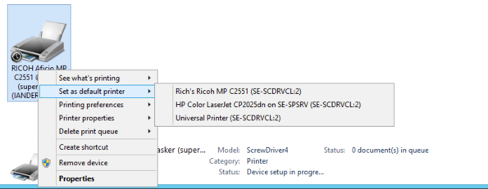

Licensing
Once you have installed the product your free 30-day trial will commence. At any time during or after the trial you may enter a product serial number and activation code to remove the trial dialog and begin full use of the software in a production environment.
YOUR INSTALLATION OF THIS PRODUCT IS SUBJECT TO TRICERAT’S END USER LICENSE AGREEMENT.
The ScrewDrivers product licenses are sold per server, per named-user, or concurrent licenses. For more information about licensing, ask your Tricerat representative.

Technical Support
Tricerat offers FREE technical support on all products during the 30-day evaluation period.
Contact Us:
- email: support@tricerat.com
- US/Canada Toll Free: (800) 582-5167
- EMEA: +44 (0)1582 638800
- Int'l: 1 (410) 715-4226

